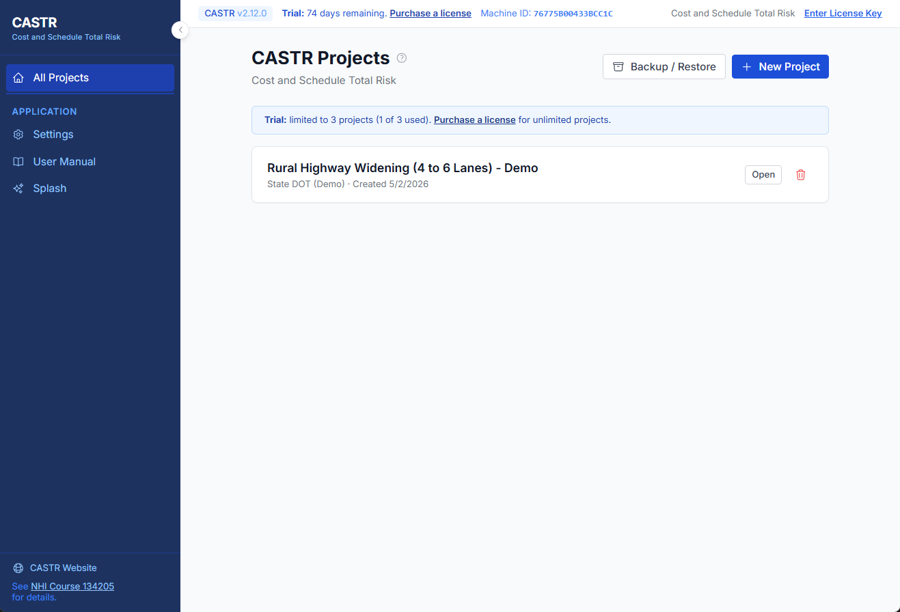
All Projects Homepage
https://app.screencast.com/qDre0j3M81A5F

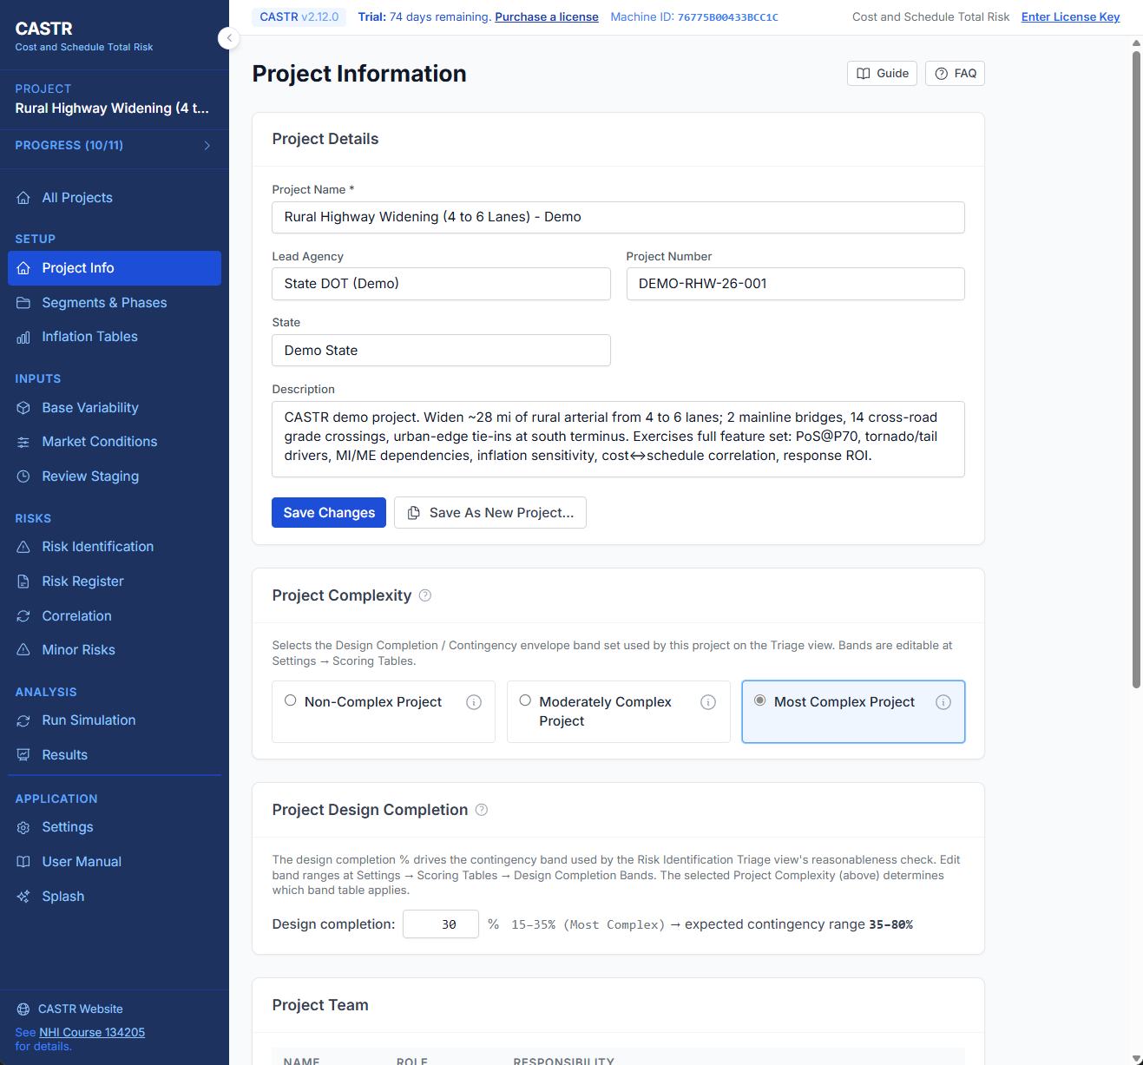
Project Information
https://app.screencast.com/E9TEhANMa7PD5

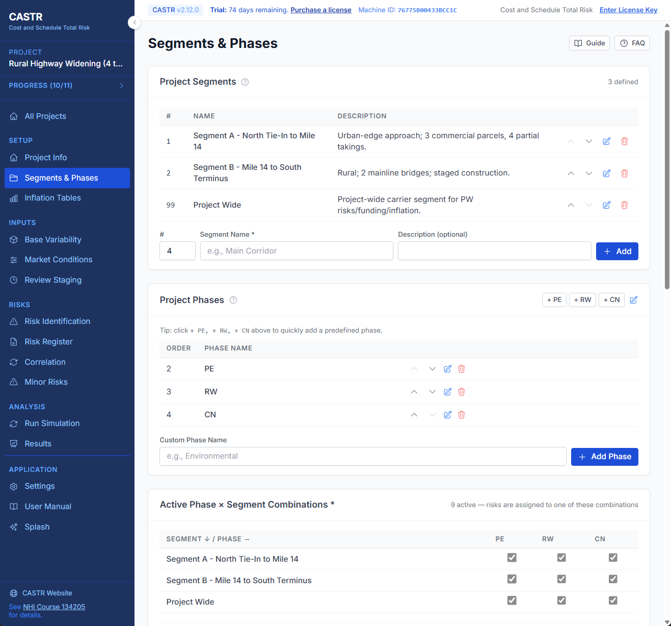
Segments and Phases
https://app.screencast.com/Z5Q9KOZhJVqvX

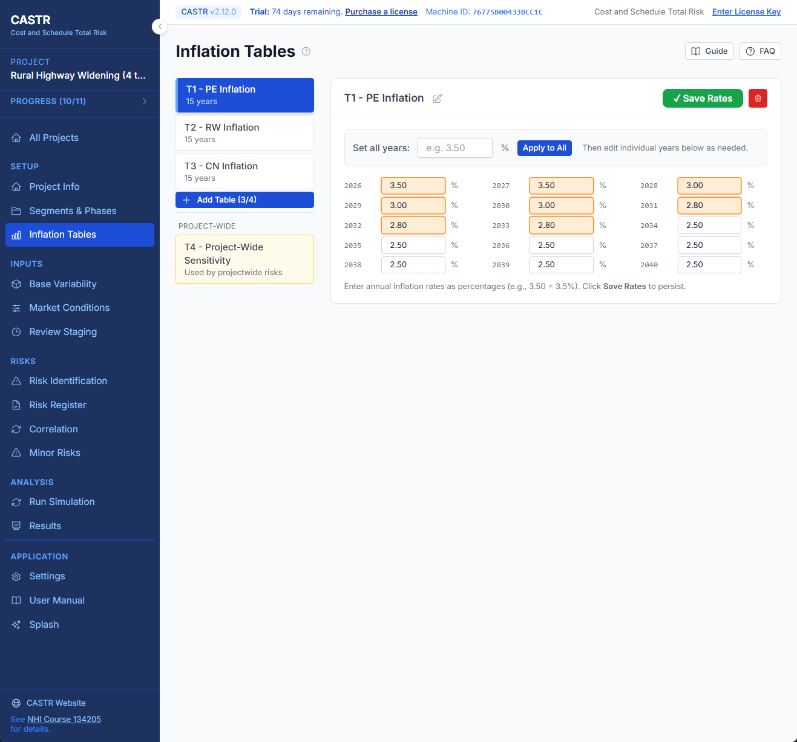
Inflation Tables
https://app.screencast.com/53p0JDgeLtIqj

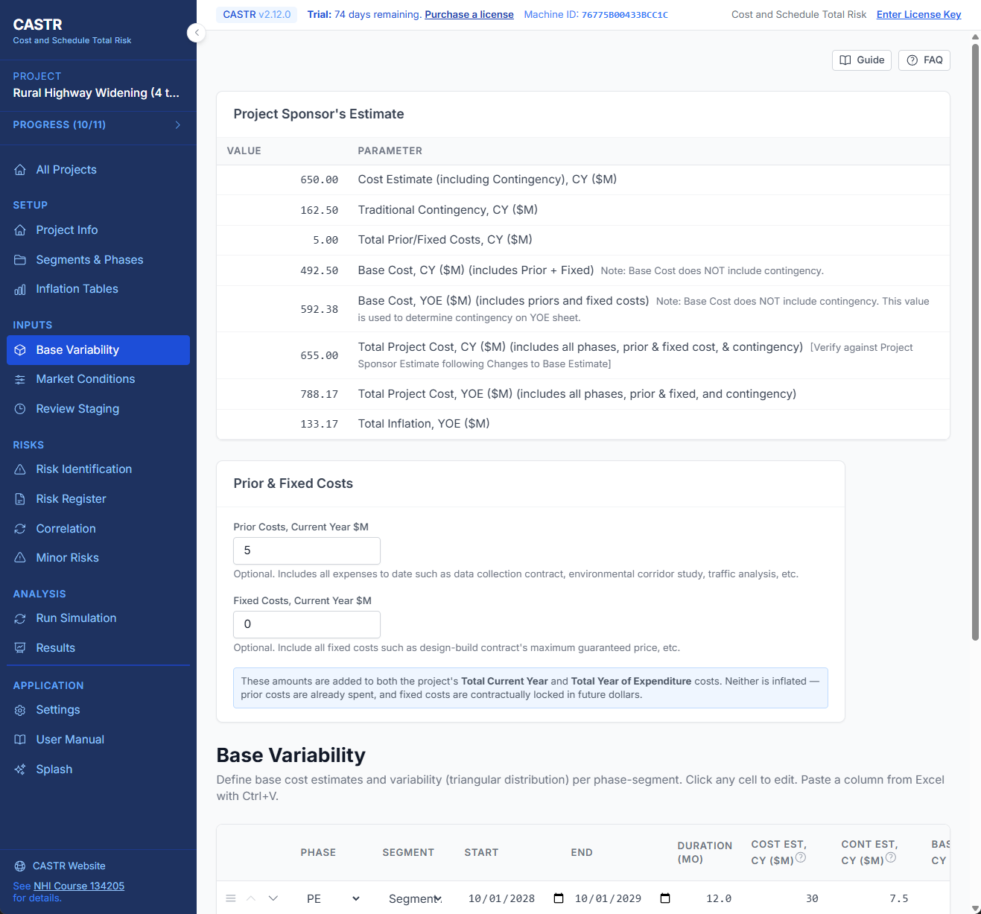
Base Variability
https://app.screencast.com/VUvlVlJpgIq43

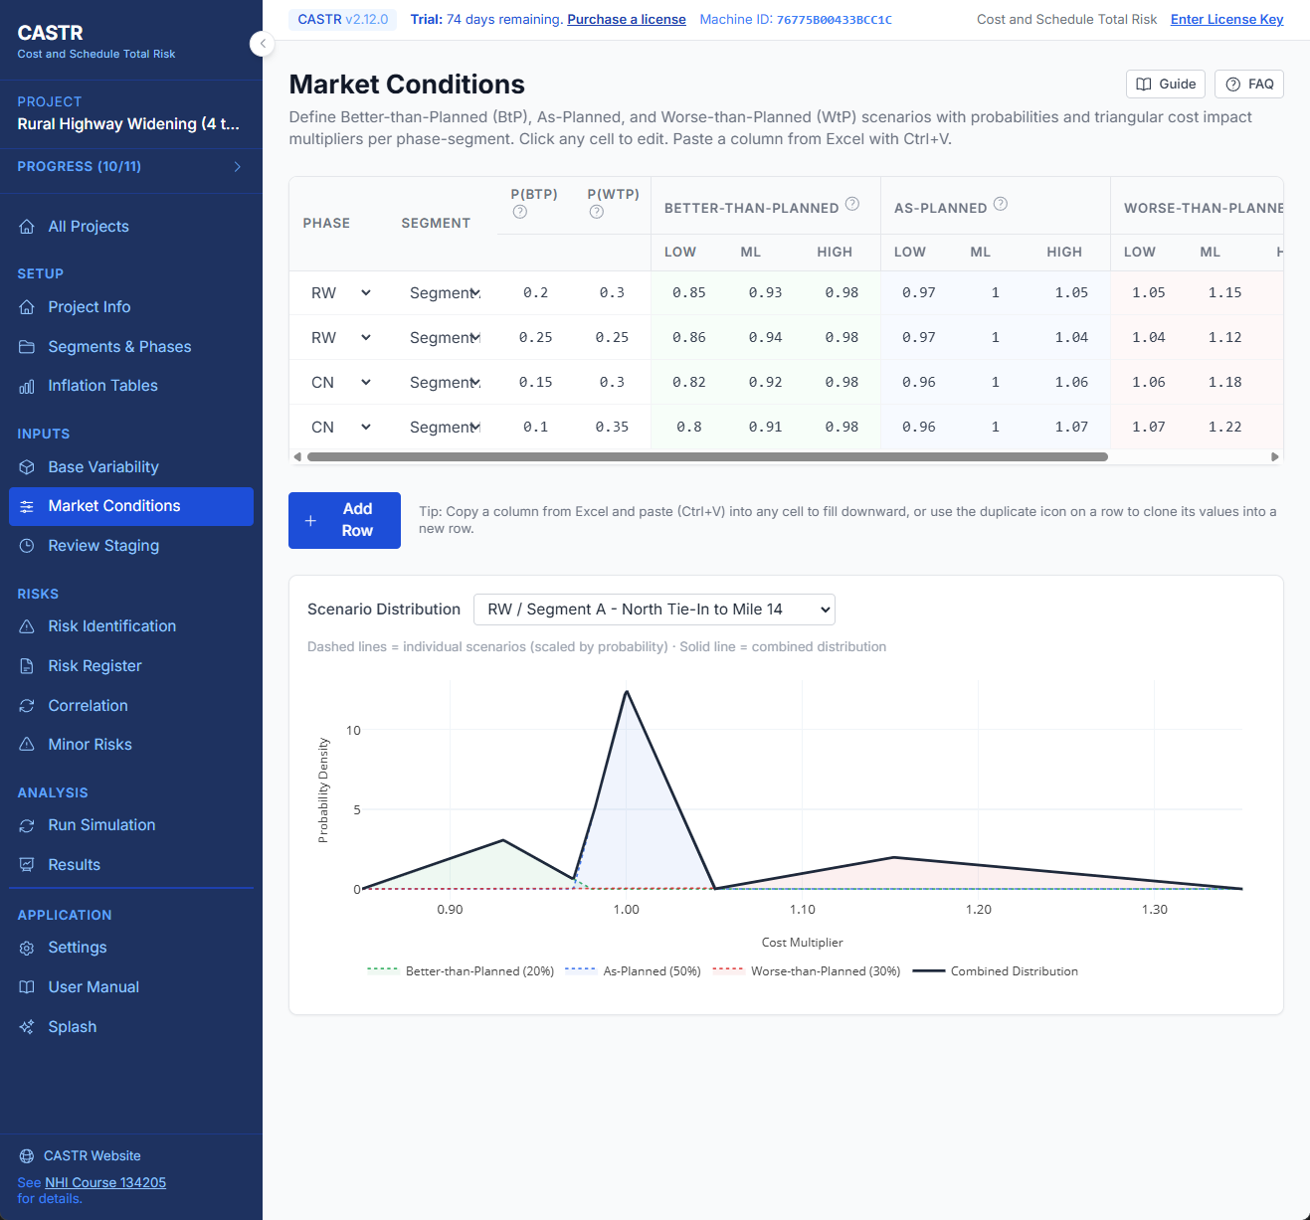
Market Conditions
https://app.screencast.com/oosmsgfHW263T

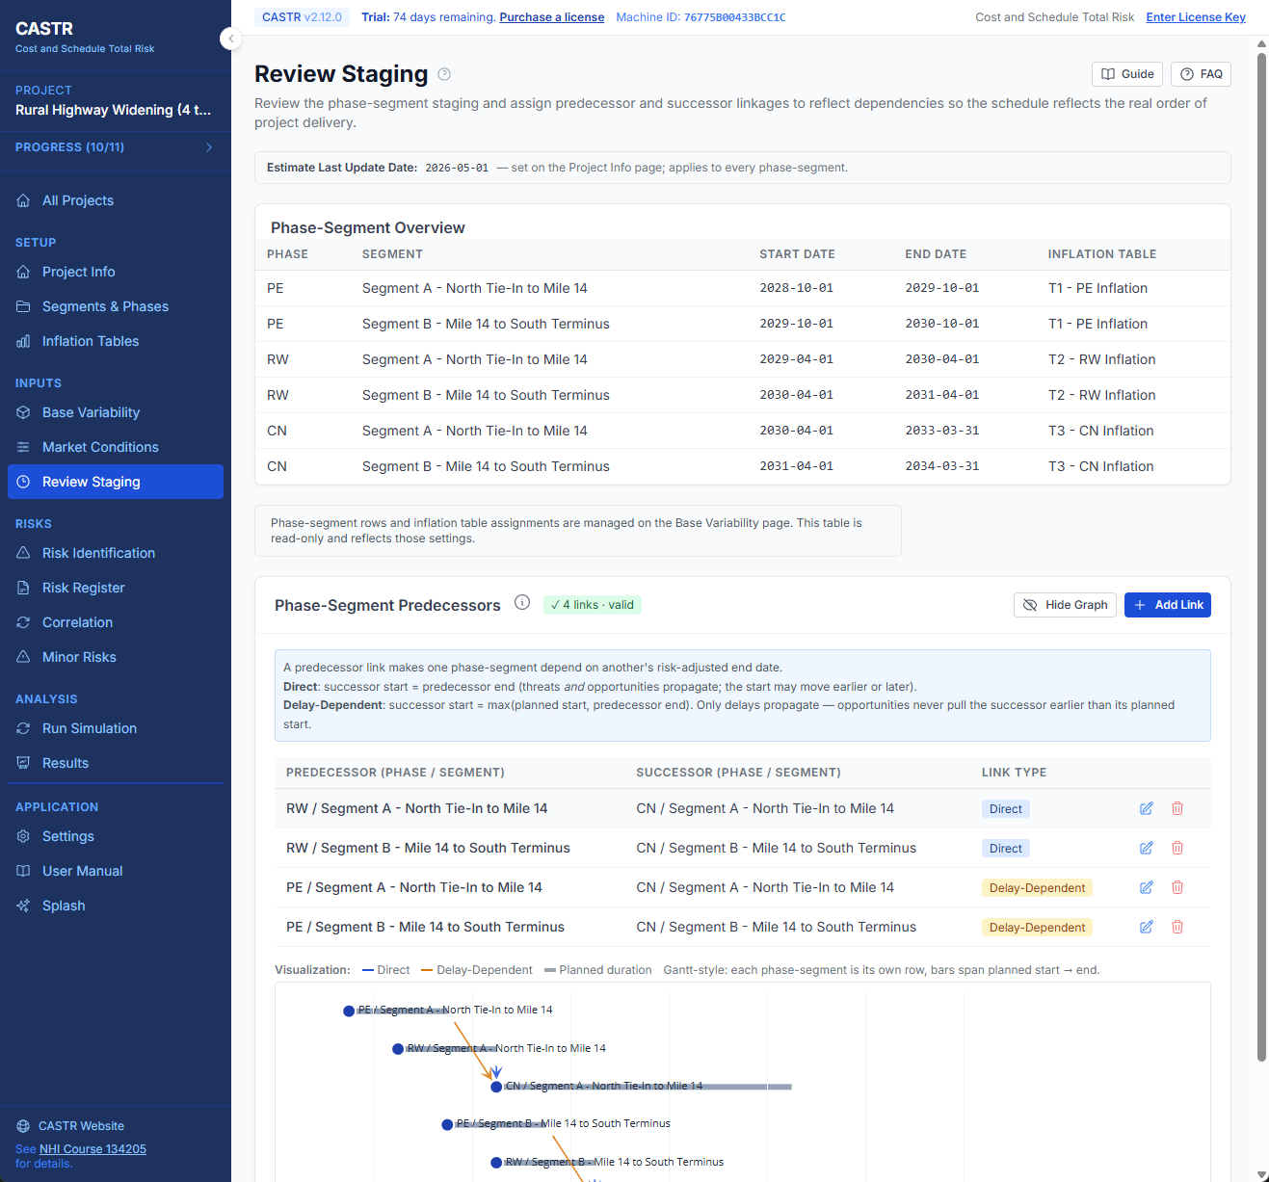
Review Staging
https://app.screencast.com/X7PNolxUsSI7I

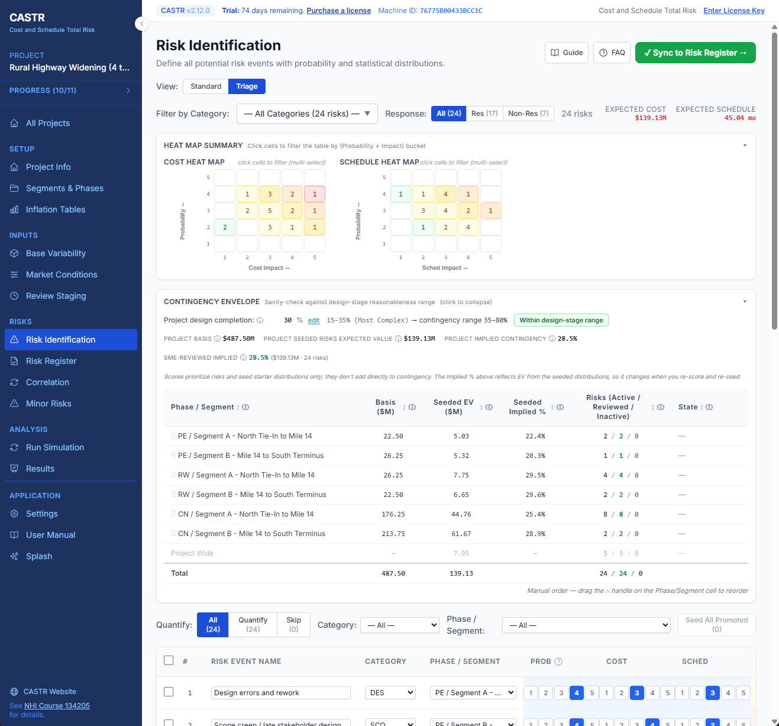
Risk Identification Triage View
https://app.screencast.com/VwZpyMomKb8dI

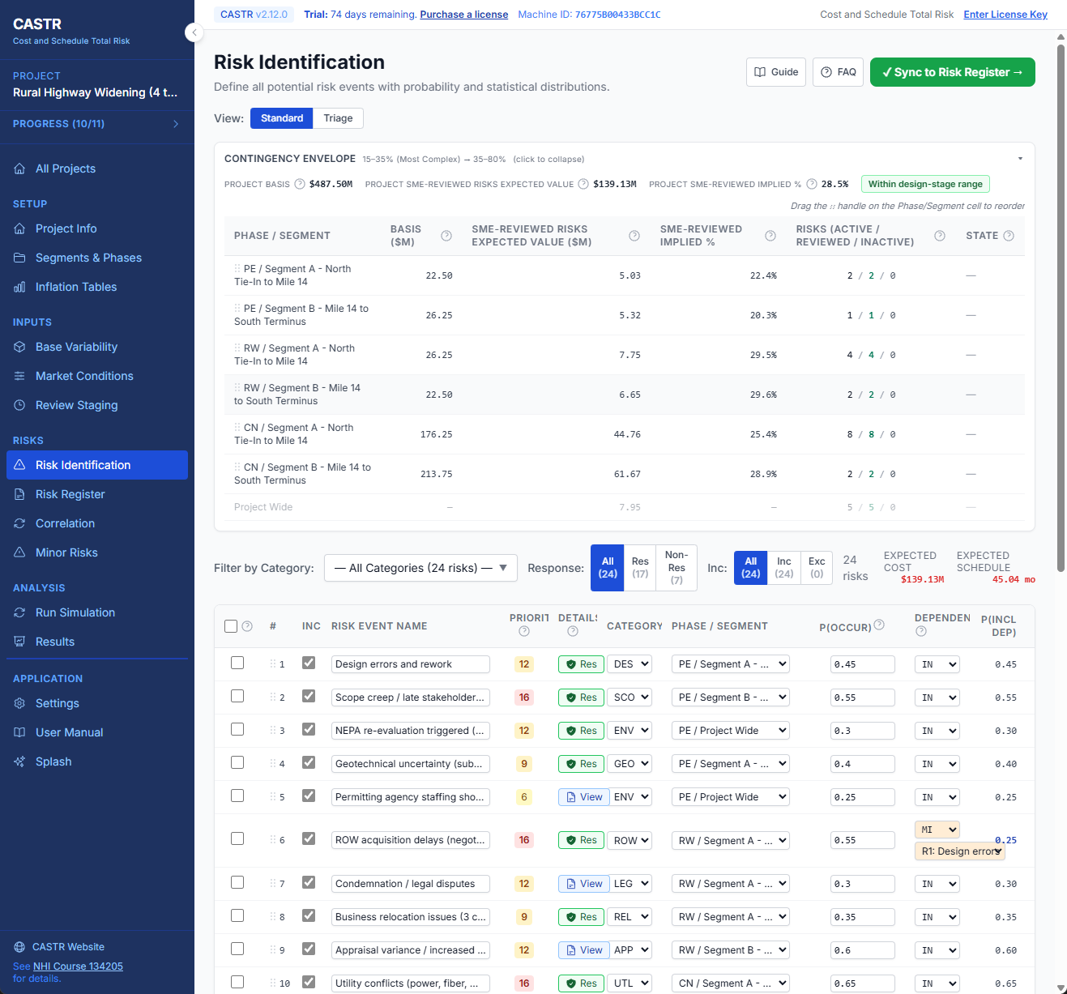
Risk Identification Standard View
https://app.screencast.com/d5XZTdOwi8D59

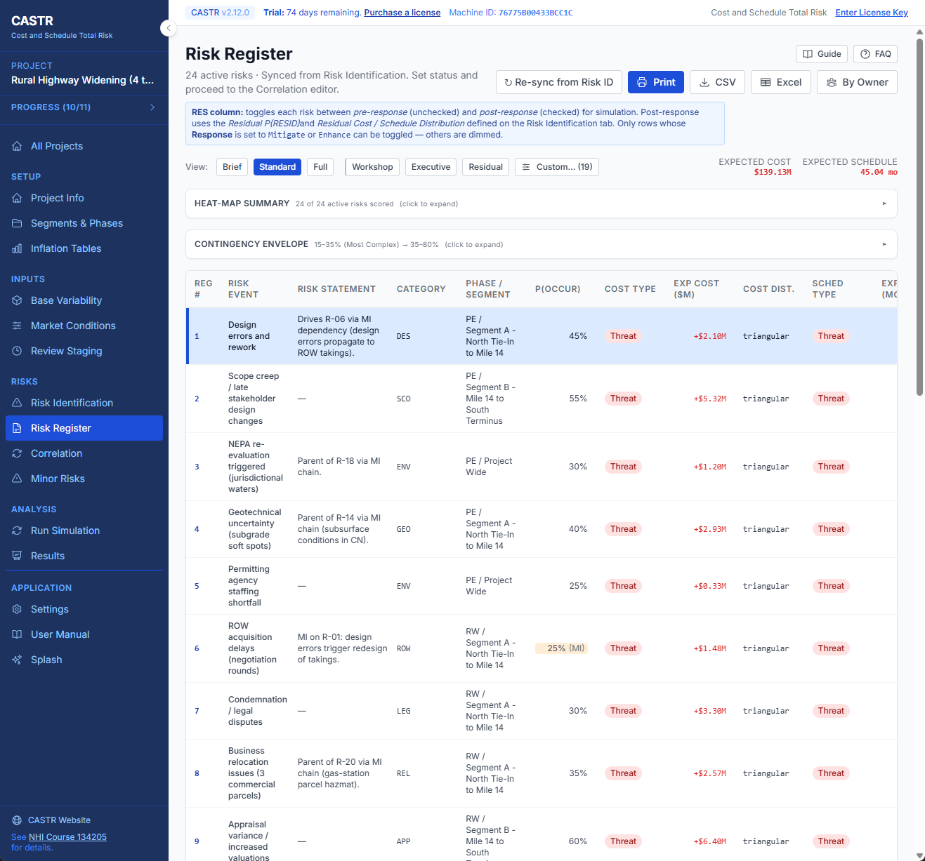
Risk Register Standard View
https://app.screencast.com/axQxeiu0xAiDF

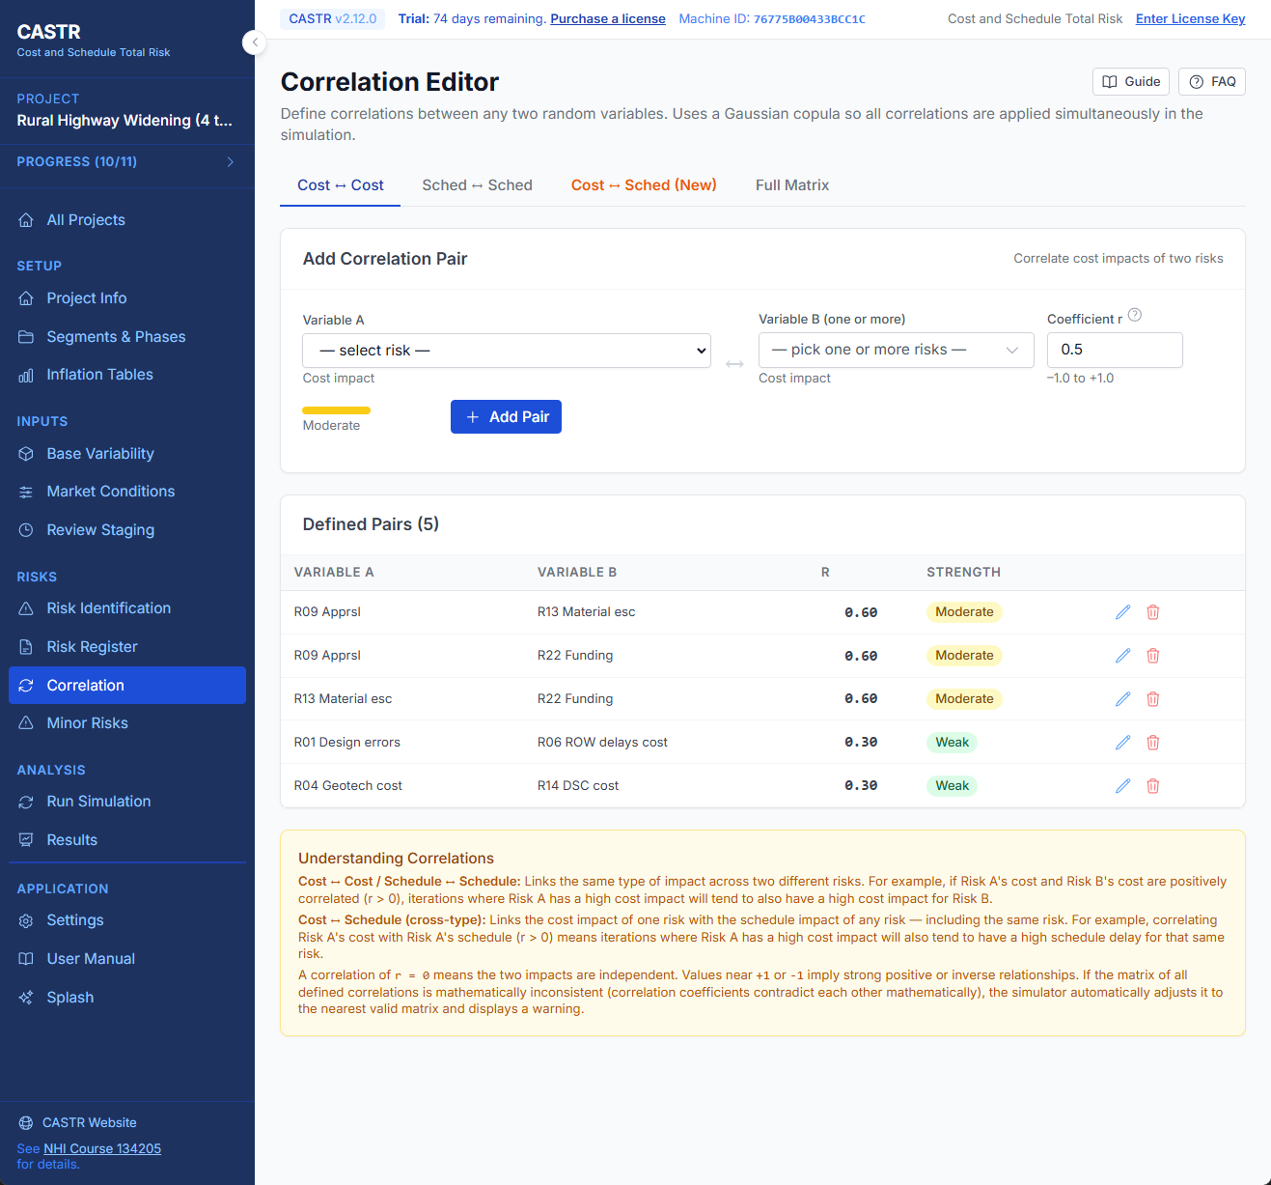
Correlation
https://app.screencast.com/NNHVtfI6u2nh3

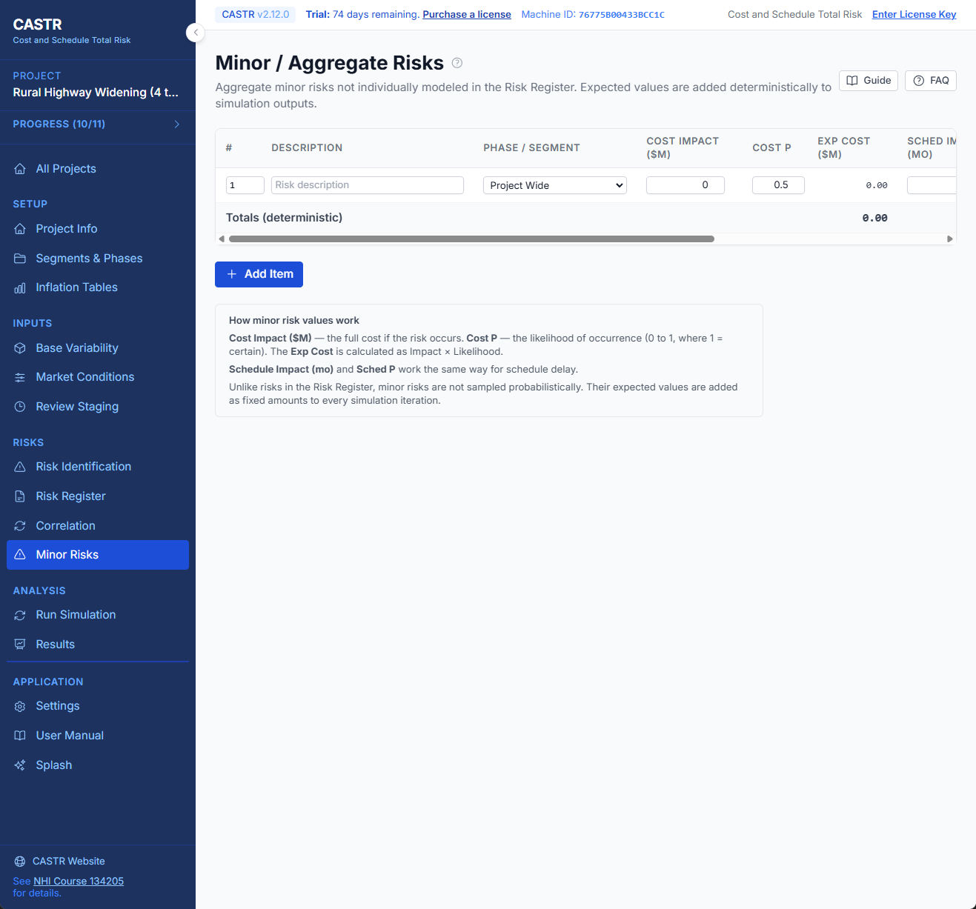
Minor Risks
https://app.screencast.com/R9PfmonTQck8L

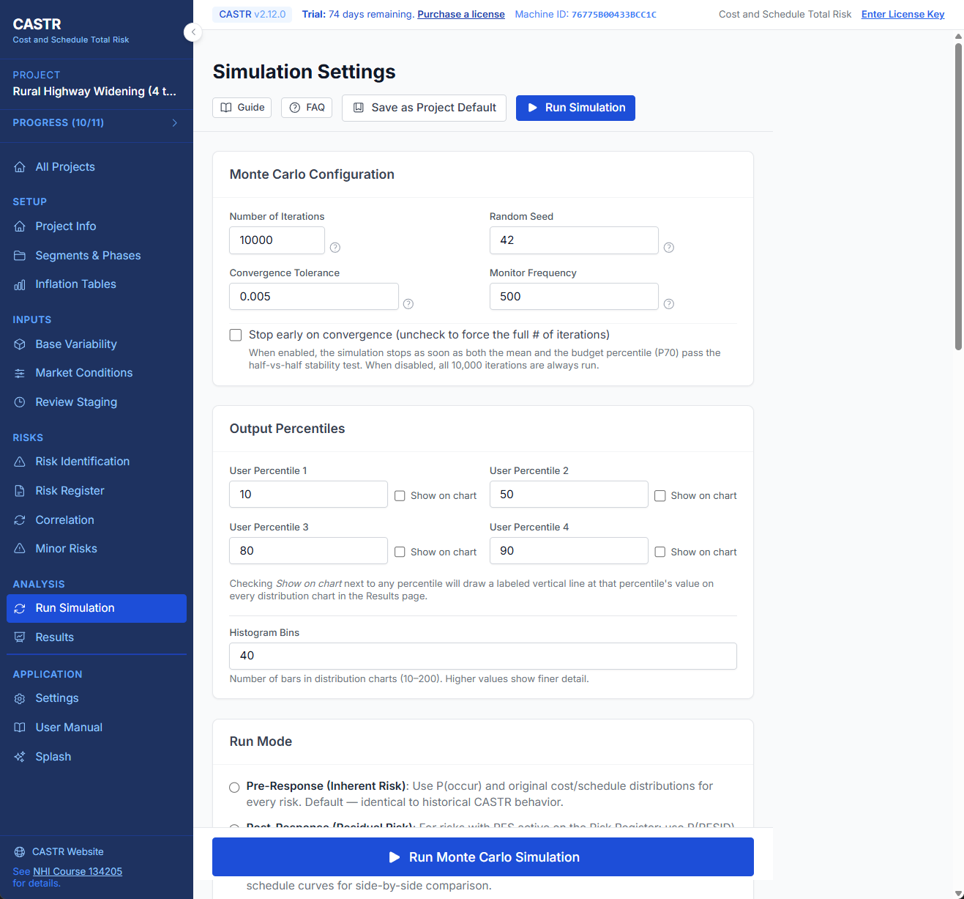
Simulation Settings
https://app.screencast.com/nuzQNfYEaKib6

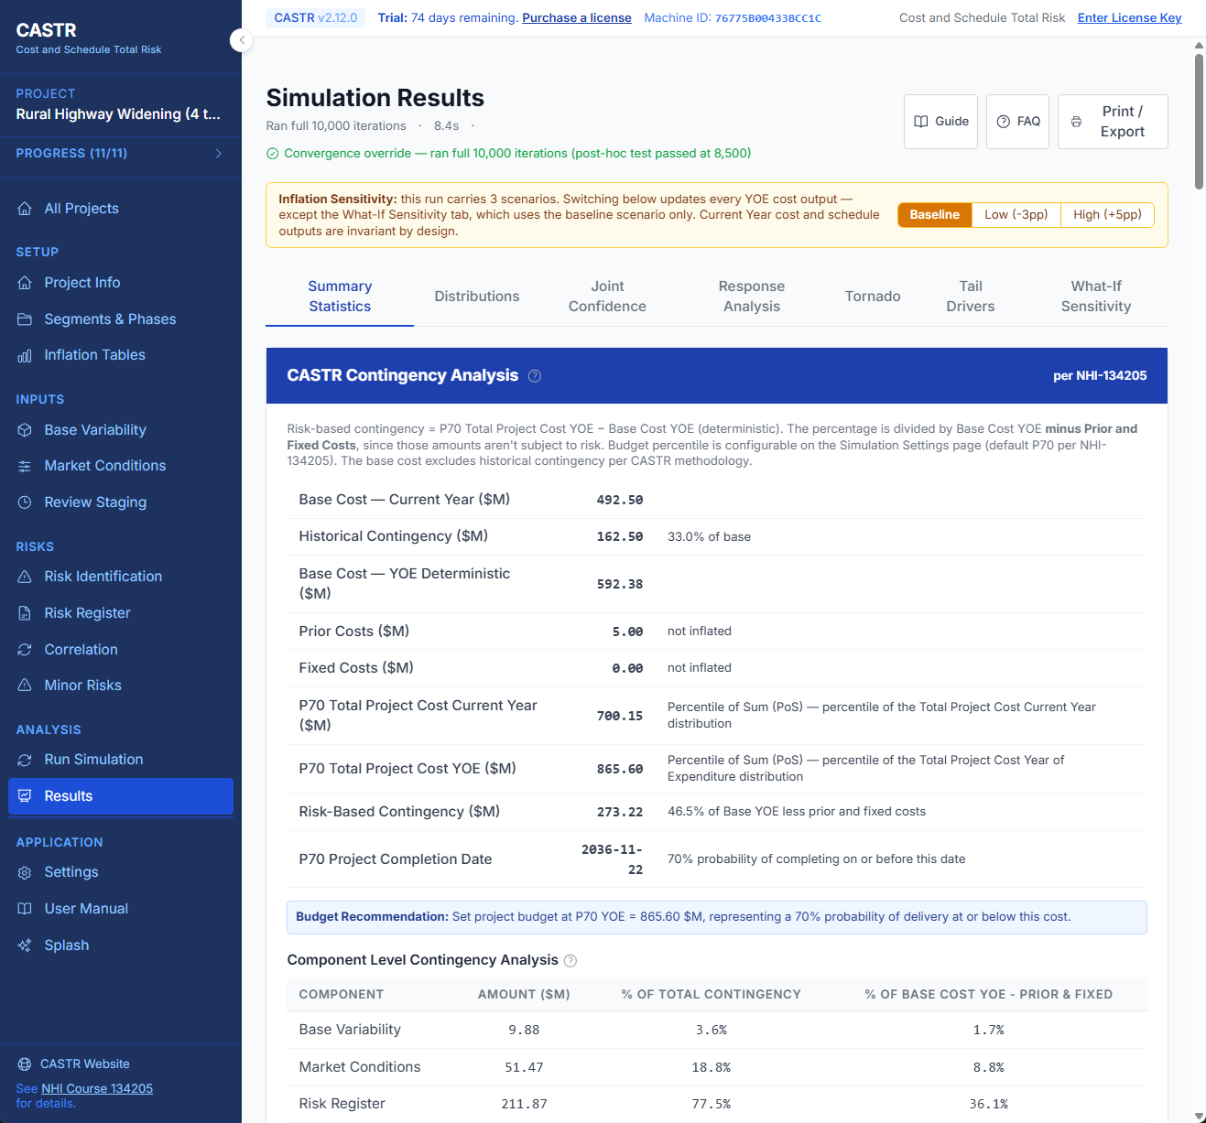
Results – Summary Statistics
https://app.screencast.com/QRKYRynV1QeAZ

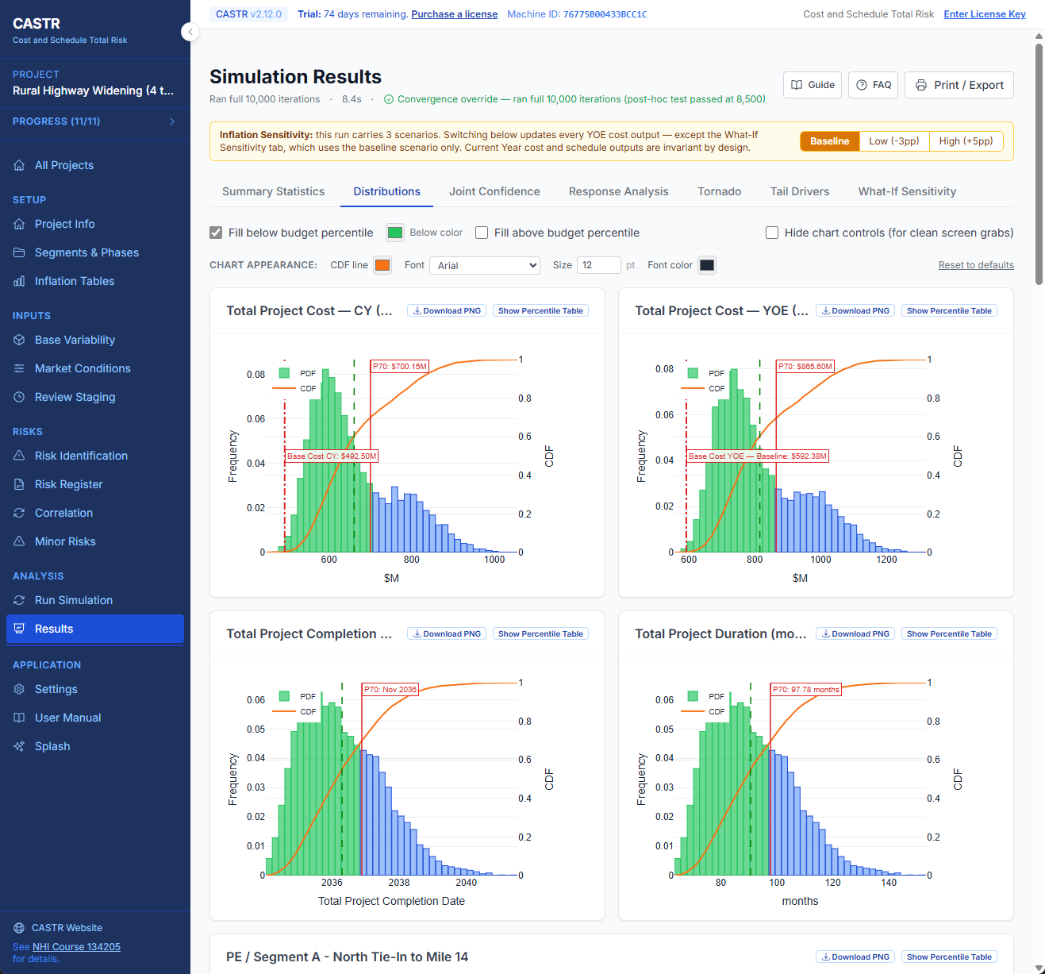
Results – Distributions
https://app.screencast.com/wiE3xAyBpWWwq

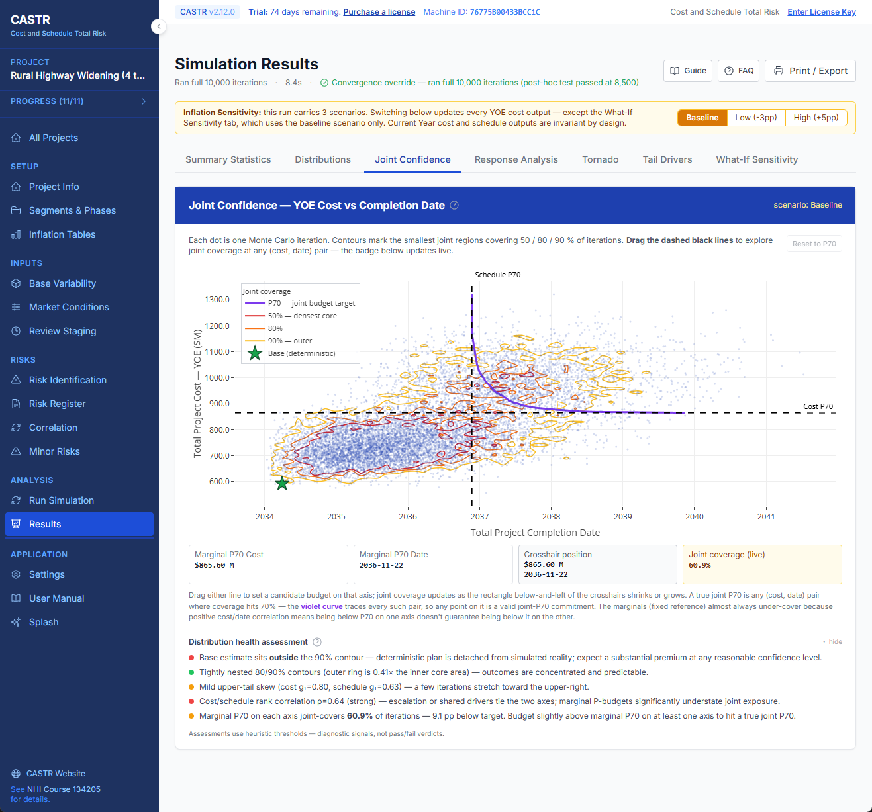
Results – Joint Confidence Distribution
https://app.screencast.com/2GPRQXfRQ4nSP

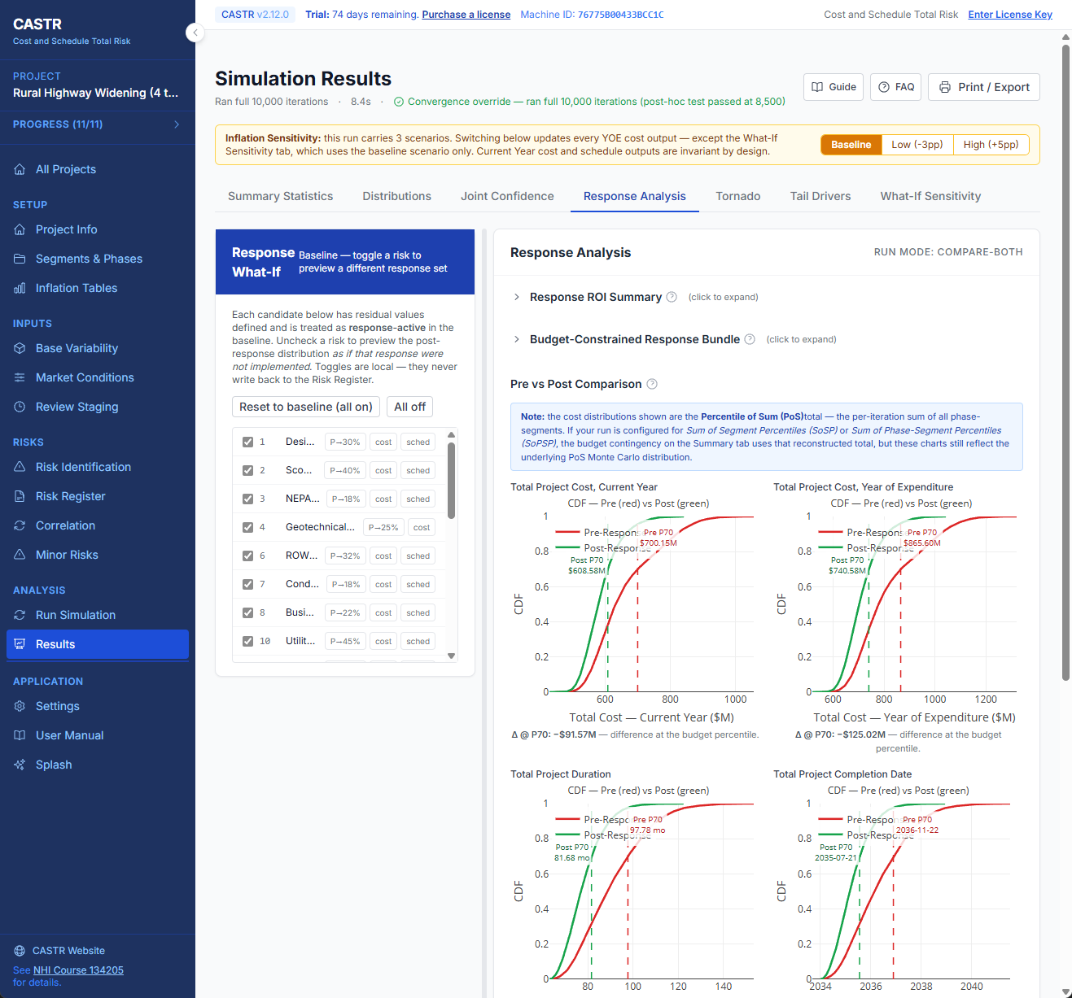
Results – Response Analysis
https://app.screencast.com/E5a1fPXQtNV2v

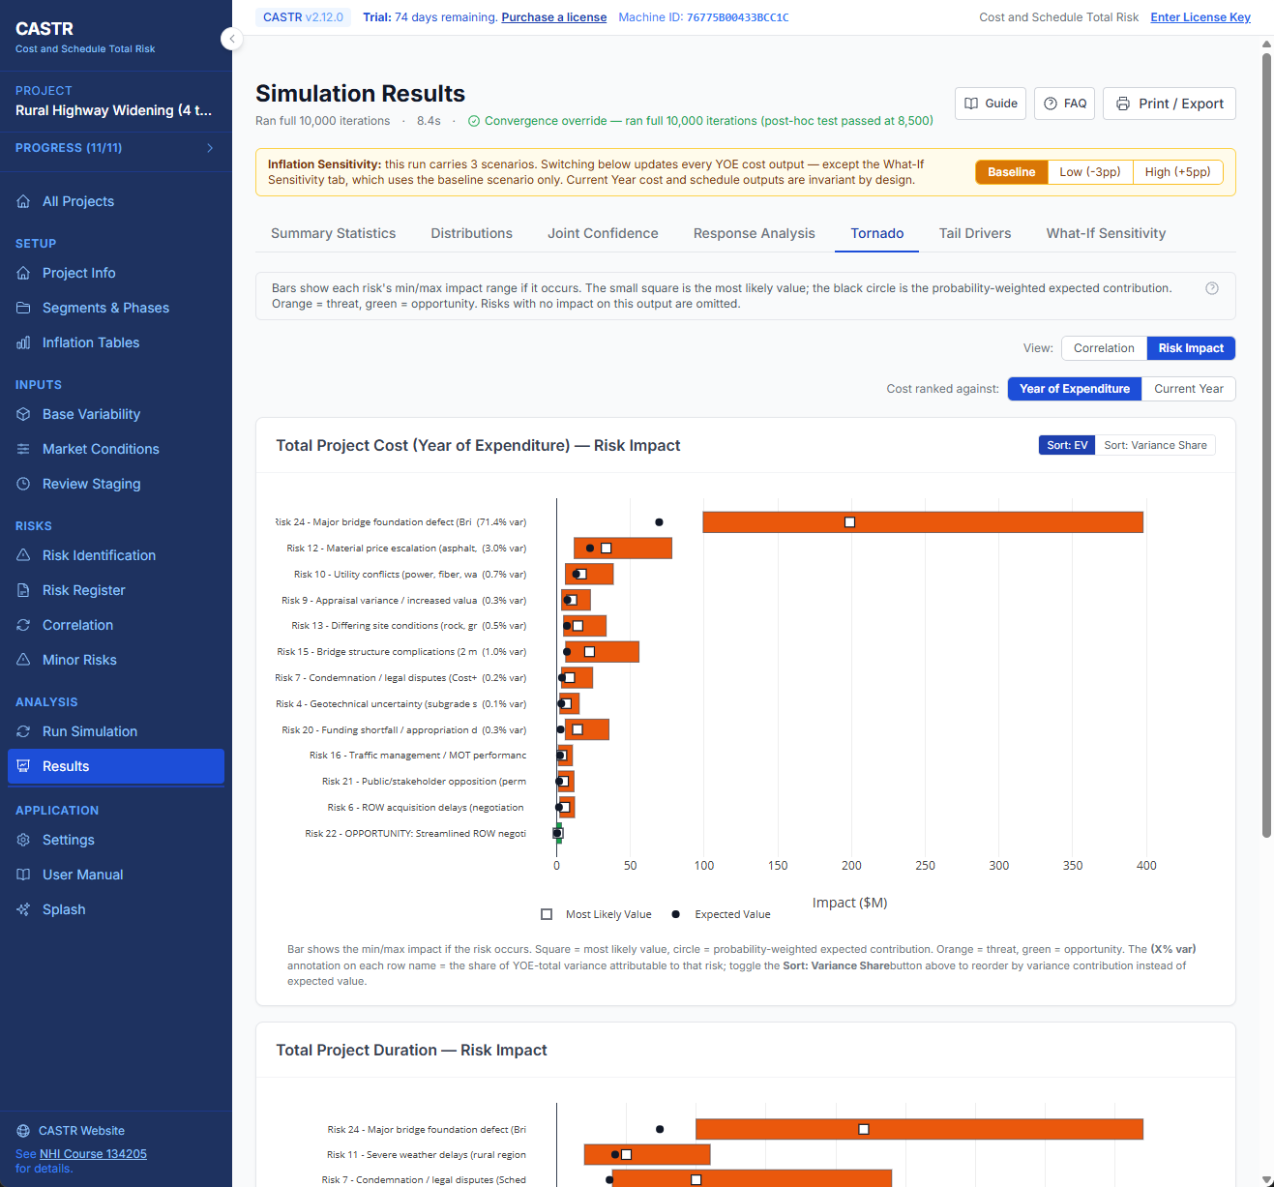
Results – Tornado
https://app.screencast.com/lpAeyoahzdPSx

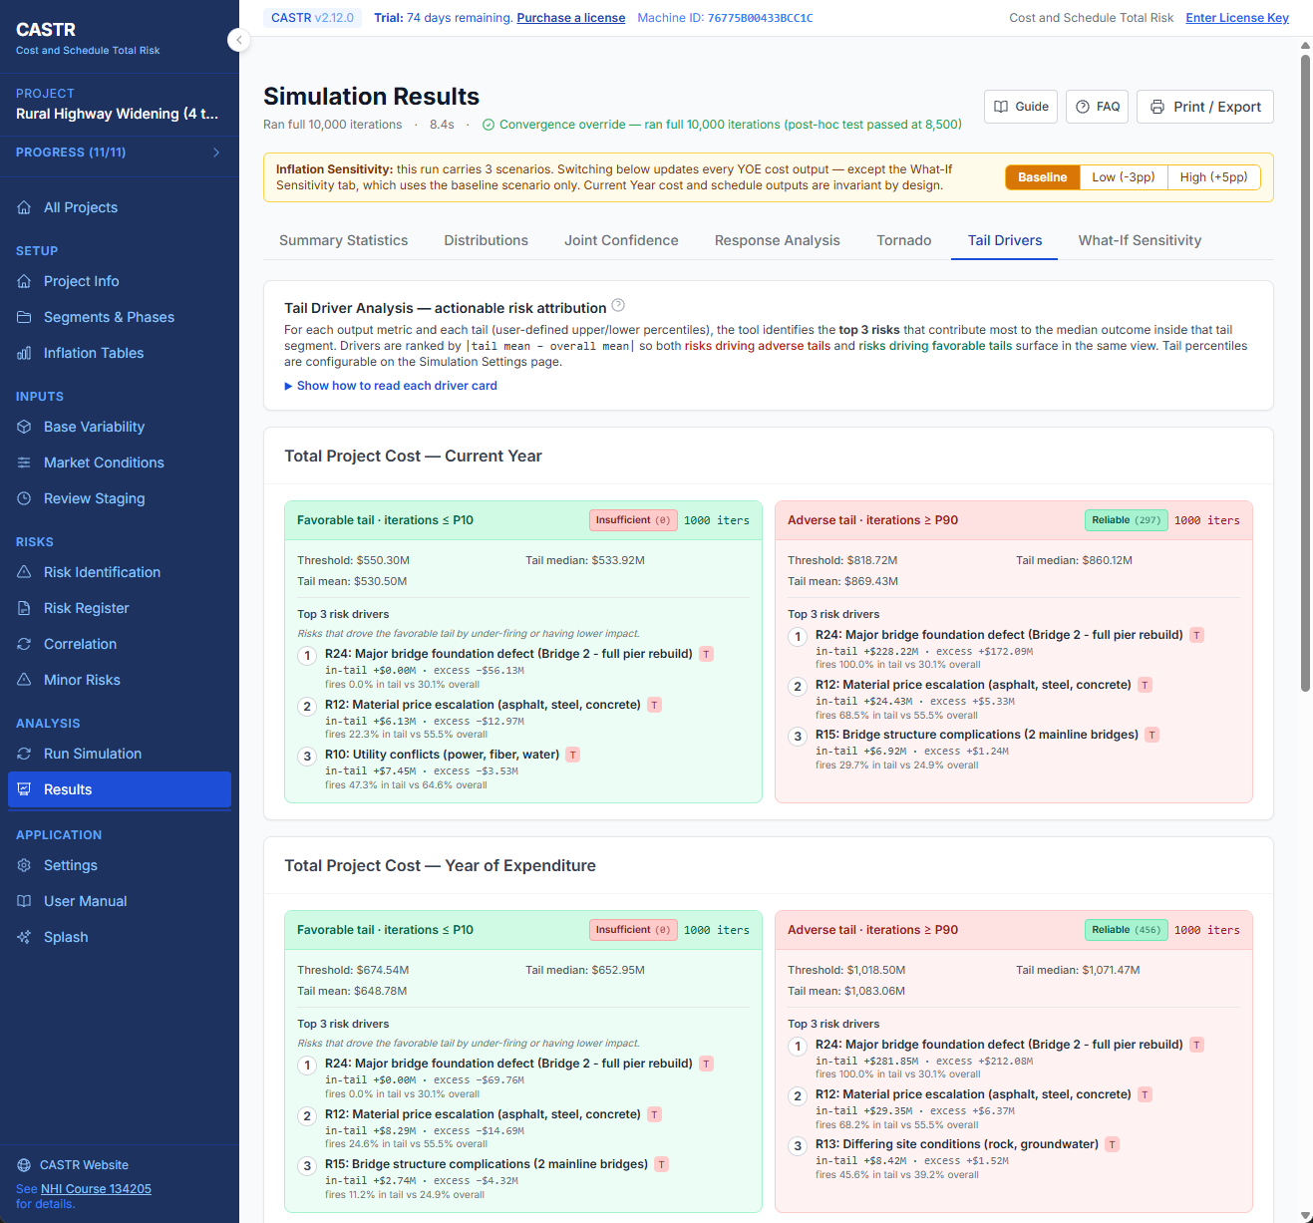
Results – Tail Drivers
https://app.screencast.com/VYshEs1Eh5v9v

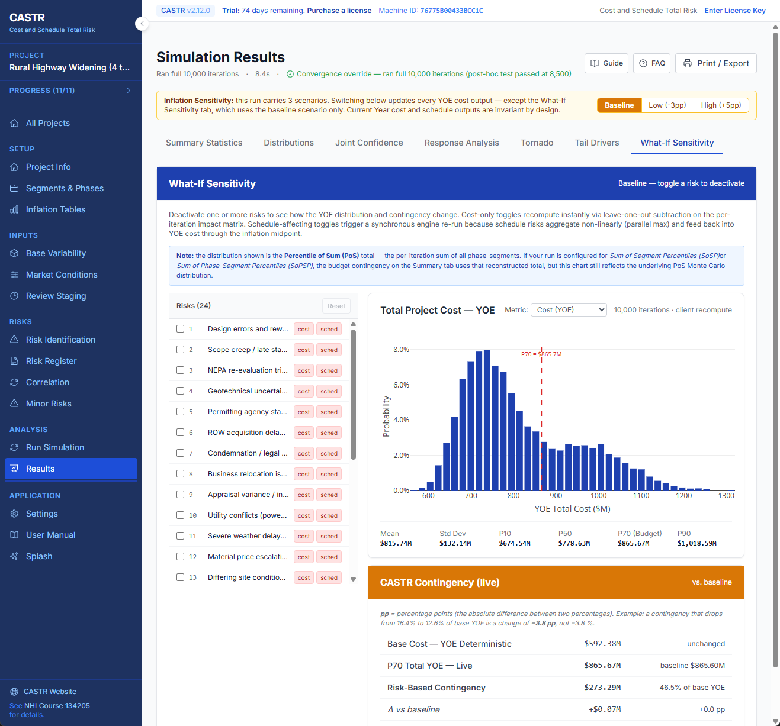
Results – What-If Sensitivity
https://app.screencast.com/vjTuIG3zM2rWd

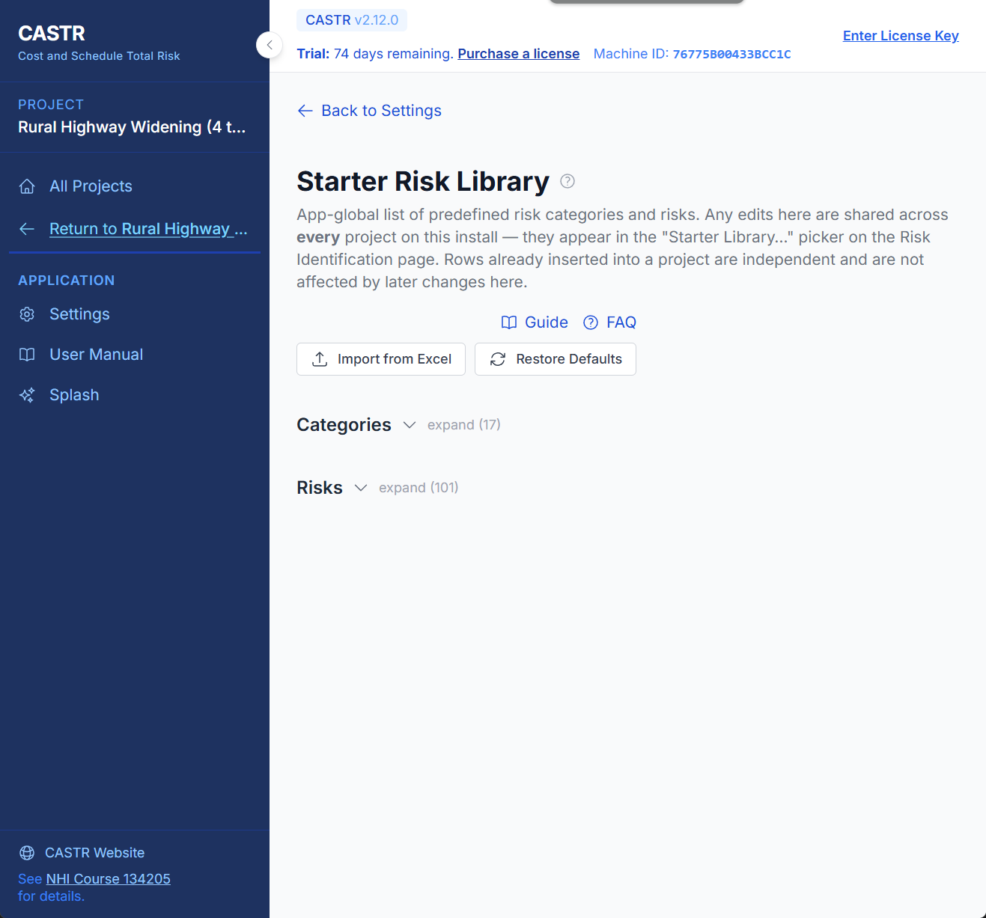
Settings – Starter Library
https://app.screencast.com/201FCb5WKwaT9

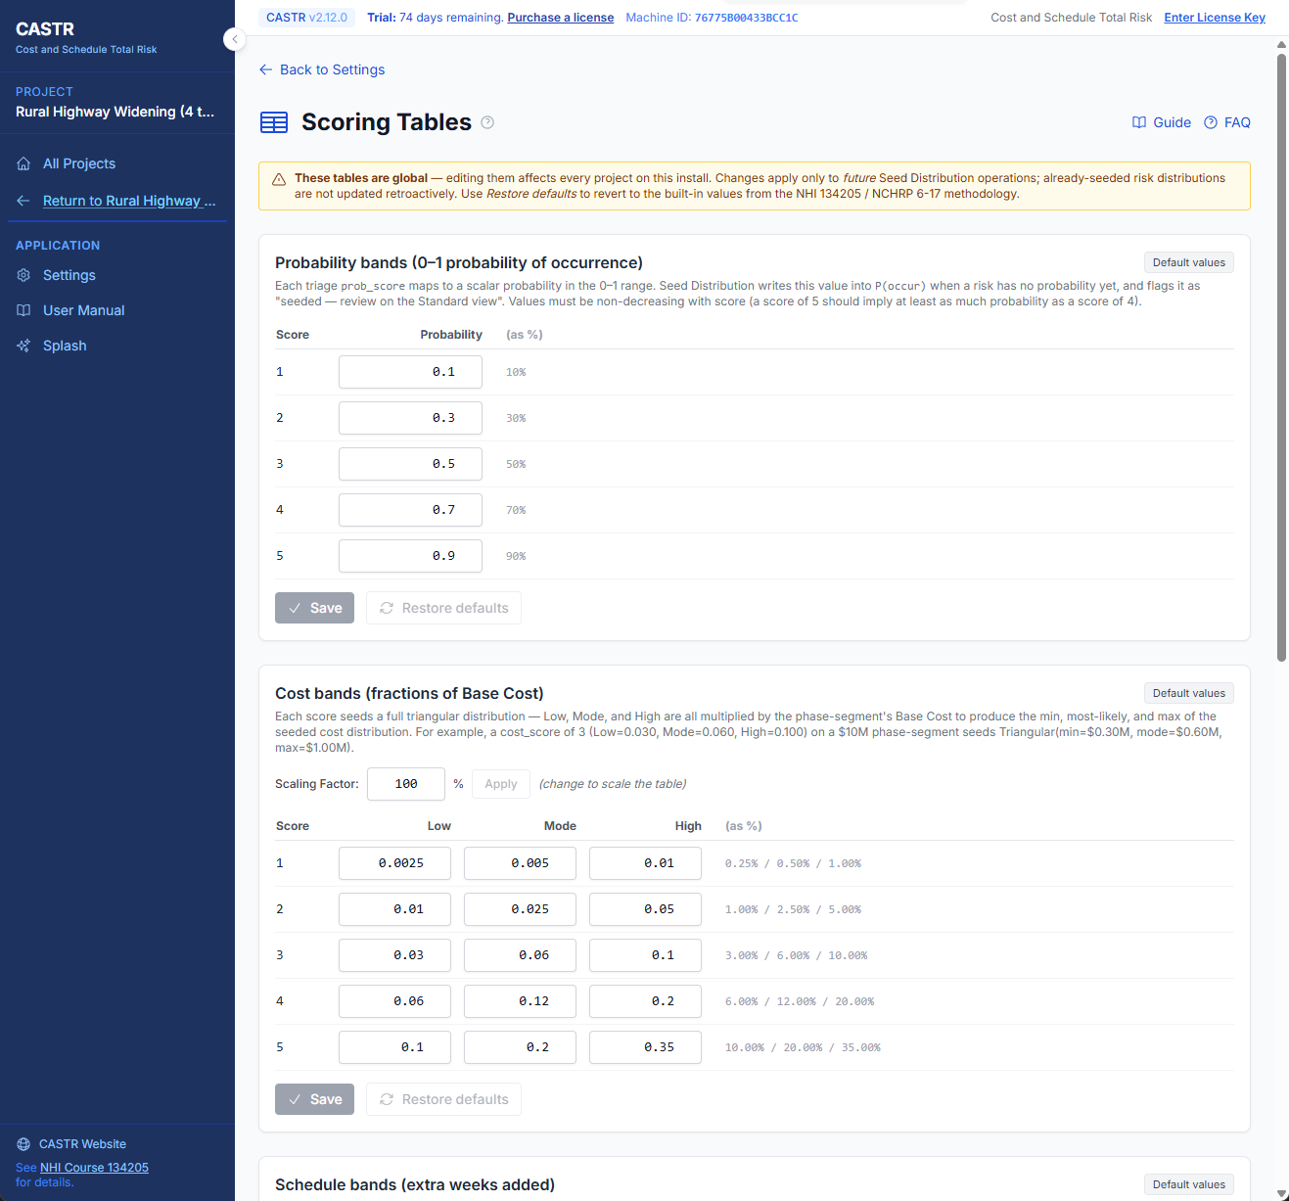
Settings – Scoring Tables
https://app.screencast.com/eRh73LaAjOREw

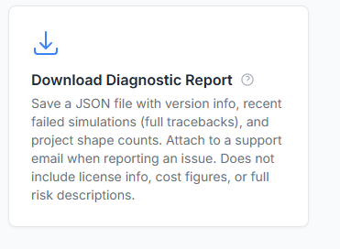
Settings – Diagnostics Report
https://app.screencast.com/d9lFlgc61Fm8c

